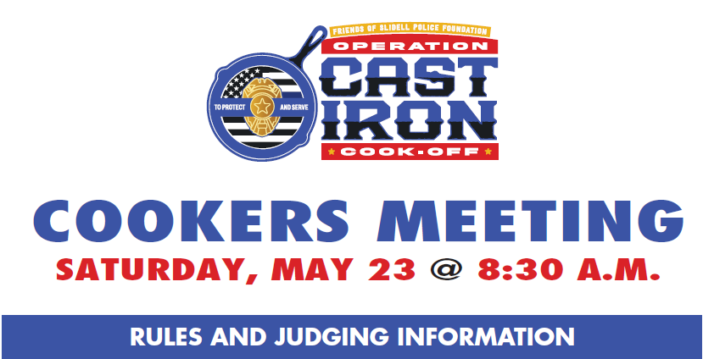
- SET-UP TIME: COOKING TEAMS will be allowed to set up in Olde Towne Slidell beginning at 4 a.m., Saturday, May 23. (Large teams may set up as early as 2 p.m. Friday, May 22 with preauthorized permission).
- PRE-EVENT MEETING: Each Team must send at least one representative to the COOKERS MEETING at 8:30 a.m. on Saturday, reporting to the Judging Tent.
  - Your team will receive 4” Cast Iron Skillets which will be used to supply samples of your cook off judging dish.
  - Each skillet will have a laminated tag with a team number and category identification. These tags are attached to the 4” Cast Iron Skillets for judging.
- CLEAN SURFACES: COOKING TEAMS must furnish a covering to put under cookers to prevent spills from staining the street.
- SAFETY: Per the Fire Marshal ALL TEAMS MUST HAVE A FIRE EXTINGUISHER at their site.
- JUDGING: Operation Cast Iron Cookoff follows a blind judging system. The laminated tags on your dish is the only identifier which is not known to the judges.
- SCORING: Each dish will be tasted by each judge. Each dish is scored by the judges as follows:
  - Flavor and Satisfaction – 40%
  - Cast Iron Skill – 20%
  - Creativity and Theme – 20%
  - Presentation – 20%
- JUDGING TIMES: A Volunteer will come to your cooking team to pick up your dish at the specified times below. The volunteer will arrive at your team 5-minutes prior to the time for the dish category. Your team has a window of 5-minutes after the turn-in time below or not be able to be judged.
- ENTRY TIMES per Dish Category:
  - Rice/Pasta 11:00AM
  - Lagniappe 11:30AM
  - Roux Noon
  - Sweet/Savory 12:30PM
  - Grillades 1:00PM
- QUANTITY of DISHES: Teams are to supply 6 servings minimum – more if possible so that the table captains and other volunteers can have a taste.
- ENTRIES: Only 1 dish entry per team per dish category will be judged.

GOOD LUCK TO ALL!

